FULL SEO · MENTORING SAAS
How a Full-SEO Strategy Grew a Mentoring SaaS Traffic by 140% in 6 Months
On-page optimization | Technical SEO | Link building

69 → 72  DR growth  +3 pts | 140%  Traffic increase  15K → 36K | 150+  Backlinks built | +1.1K  New organic keywords  +14% growth

Overview
Our client is a mentoring SaaS platform helping organizations run structured mentoring programs at scale. Despite operating in a competitive niche, they had untapped organic potential — and needed a partner to unlock it.
Over 6 months, we deployed a Full SEO strategy combining on-page optimization, consistent content publishing, technical fixes, and 150+ targeted backlinks. The results speak for themselves: DR climbed from 69 to 72, monthly organic traffic more than doubled from 15K to 36K — a 140% increase — and the site added 1.1K new organic keywords, a 14% growth in keyword coverage.

Overall site performance
The snapshot below shows where the site stands today. DR 72, 39.3K organic traffic, 3.9K organic keywords, and 1.6K referring domains — all meaningful gains driven by sustained, multi-channel SEO work.
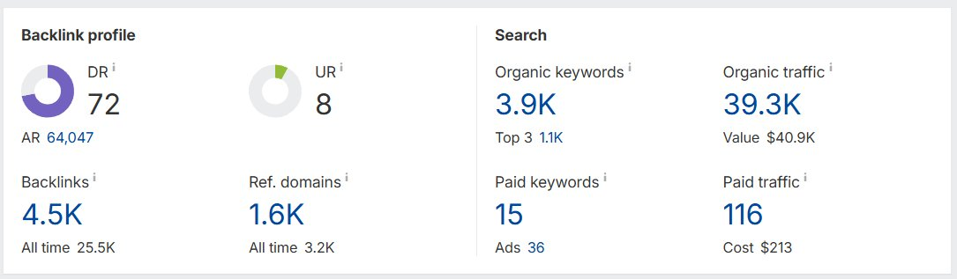

Keyword performance highlights
Three keywords that show the depth of results — including a position 3 to #1 jump on a high-CPC term, a 9-spot climb to the top spot on a competitive keyword, and a brand new entry already ranking in the top 10.
Keyword #1 — position 3 → 1
Volume 450 KD 49 Position change ▲2

Blurred screenshot (keyword hidden):
Original screenshot:
Despite a KD of 49, this high-value keyword (CPC $17.74) moved from position 3 to #1, generating +118 in traffic. Ranking first for a commercial keyword at this difficulty is a direct signal of growing domain authority and content quality.
Keyword #2 — position 10 → 1
Volume 100 KD 66 Position change ▲9

Blurred screenshot (keyword hidden):
Original screenshot:
With a KD of 66, this was one of the tougher targets. The page climbed 9 positions — from page 2 to the very top of Google — adding +8 in traffic. Breaking through to #1 on a high-difficulty keyword signals that the site now has real authority in its niche.
Keyword #3 — new entry at position 6
Volume 50 KD 49 Position Not ranked → #6

Blurred screenshot (keyword hidden):
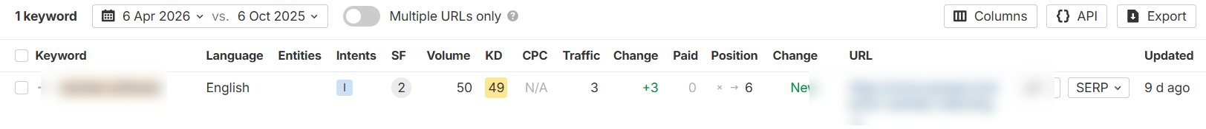
Original screenshot:
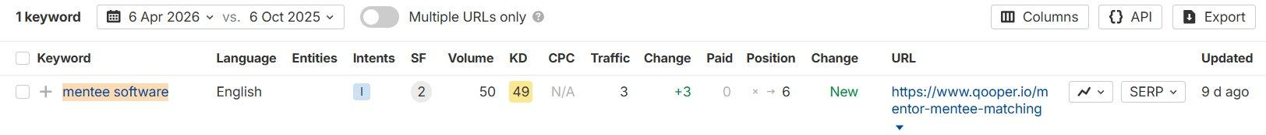
This keyword entered the rankings fresh and immediately landed at position 6. For a page that wasn't ranking at all, breaking into the top 10 on a KD 49 keyword this quickly reflects the compounding effect of technical improvements and link building.

What drove these results
Six months of consistent, multi-pillar SEO — not a single shortcut.

Consistent blog publishing  We regularly produced and published new blog articles targeting high-opportunity keywords, creating new organic entry points month after month. | On-page optimization  Existing pages were continuously reviewed — updating meta data, improving content structure, strengthening internal links, and aligning pages with search intent.
150+ backlinks built  We built over 150 unique backlinks from relevant, high-authority domains, growing the domain rating from 69 to 72 over 6 months. | Technical improvements  Crawlability, indexation, and Core Web Vitals issues were resolved on an ongoing basis, ensuring nothing technical held back organic potential.

